12/26/2019

GROUP MEMBERS

NABIHA WAHEED KHAN. (01-235-192-104) SHAHEER ANIS. (01-235-192-075) NOMAN AZEEM. (01-235-192-053)

Contents

LIBRARY 2

SCOPE: 2

CODE: 2

HTML CODE 2

CSS CODE: 3

SCREEN SHOOT OF WEBSITE PAGES: 7

HOME PAGE: 7

BOOKS PAGE: 7

GALLARY PAGE: 8

CONTACT PAGE: 8

LIST OF BOOKS PAGE: 9

LEARN MORE: 9

PROJECT:

# LIBRARY MANAGEMENT SYSTEM

This website is made on a library. It is made to help people to read books online. Books are all free to read. People can contact us via Gmail or text. They can send us feedback. Anyone is not restricted; they can go anywhere in any page. **BOOK** page is designed in such a way that the pictures of the images are displayed and user can open that book by clicking on that Book.in **GALLERY** we have displayed the structure of the library from inside and outside, how the books are arranged and about the sitting management inside library. In **CONTACT** page all the information about us is given. A user can contact us via Mail, text or contact. In **LIST OF BOOKS** page, we have provided a short description about the **Authors** of the books and list of books in library of those **Authors.** In **LEARN MORE** page our information is given. Then a brief information about our library is given. Some of its SPACIALITIES with their description are also given. Through **RESERVATION** page a user can reserve a book or cancel the reservation by giving his Name, ID, Address, Phone number, E-mail.

## OBJECTIVES:

The main objective of the website is to automate the existing system of manually maintain the record of the Book Issue. Book Return from student etc. So the book Issue, Return, Searching will be faster.

## SCOPE:

This website can be used by any Library to automate the process of manually maintaining the records related to the subject of maintaining the books Issue. Facility to reserve books that are available. Facility to cancel the reservation for a book made earlier. Online books are available.

## CODE:

A template of html code:

### HTML CODE

<!DOCTYPE html>

<html>

<head>

<title>TITLE HERE - MyLibrary< / title>

<link rel = "stylesheet" href = "css/style.css" type = "text/css" / >

< / head>

<body>

<div id = "header">

<div class = "logo">

<a href = "index.html">< / a>

< / div>

<ul>

<li class = "active"><a href = "index.html">Home< / a>< / li>

<li><a href = "BOOKS.html">Books< / a>< / li>

<li><a href = "gallery.html">Gallery< / a>< / li>

<li><a href = "#">About< / a>< / li>

<li><a href = "contact.html">Contact< / a>< / li>

< / ul>

< / div>

<div id = "main">

<div class = "title"><h1>TITLE HERE< / h1>< / div>

TEMPLATE!!!

< / div><!--MAIN-->

<div id = "footer">

&copy; MyLibrary

< / div>

< / body>

< / html>

### CSS CODE:

*{

margin: 0;

Padding: 0;

font-family: century gothic;

}

body /*background*/

{

margin:0;

padding:0;

background-image: linear-gradient(rgba(0,0,0,0.5),rgba(0,0,0,0.5)), url(../img/images.jpg);

background-size: cover;

min-width: 900px;

}

#header

{

background-size: cover;

background-position: center;

height:80px;

}

#header .logo a

{

float: left;

margin:10px;

width: 300px;

height: 60px;

border:none;

background: url(../img/logo.png) no-repeat;

background-size: 300px 60px;

}

/*HEADER -> Menu*/

#header ul

{

float: right;

list-style-type: none;

margin-top: 25px;

}

#header ul li

{

display: inline-block;

}

#header ul li a

{

TEXT-DECORation: none;

color: white;

padding: 5px 20px;

border: 1px solid transparent;

transition: 01.0s ease;

}

#header ul li a:hover

{

background-color: aqua;

color: #000;

}

#header ul li.active a

{

background-color: aqua;

color: #000;

}

#main

{

max-width: 1200px;

margin: auto;

text-align: center;

min-height:400px;

width:75%;

background-color: whitesmoke;

padding: 8px 40px 20px 40px;

box-sizing: border-box;

border-radius: 8px;

box-shadow: 0 0 20px #000000b3;

font-family: "Montserrat" ,sans-serif;

}

#footer

{

margin-top:10px;

border-top:solid 1px #fff;

padding:5px;

color:white;

font-weight: bold;

font-size: smaller;

text-align: center;

}

#footer a

{

color:aqua;

}

.title

{

}

.title h1

{

color: #00AAAA;

font: 70px;

}

.title.title-light h1

{

color: aqua;

}

.CENTER

{

position: absolute;

top: 50%;

left: 50%;

transform: translate(-50%,-50%);

}

.btn

{

border: 2px solid #00AAAA;

box-sizing: border-box;

border-radius: 8px;

padding: 10px 30px;

background: aqua;

text-decoration: none;

transition: 01.0s ease;

cursor: pointer;

font-weight:bold;

color:#003333;

}

.btn:hover

{

background-color: #00CCCC;

border-color: #008888;

color: #000;

}

.border

{

border: 1px solid aqua;

color:white;

padding: 10px 30px;

text-decoration: none;

transition: 01.0s ease;

text-transform: uppercase;

cursor: pointer;

}

.border:hover

{

border: 1px solid #004444;

color:black;

background-color: aqua;

}

/*GALLERY*/

.gallery {

display: flex;

flex-wrap: wrap;

padding: 0 4px;

}

/* Create four equal columns that sits next to each other */

.gallery .column

{

flex: 20%;

max-width: 25%;

padding: 0 4px;

}

.gallery .column img

{

margin-top: 8px;

vertical-align: middle;

width: 100%;

}

.gallery .column .des

{

color:black;

}

## SCREEN SHOOT OF WEBSITE PAGES:

### HOME PAGE:

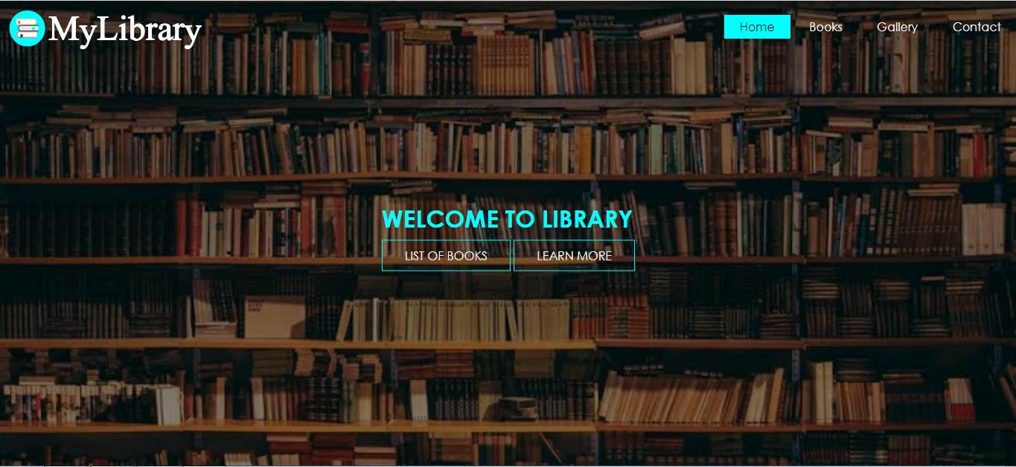

Figure HOME

### BOOKS PAGE:

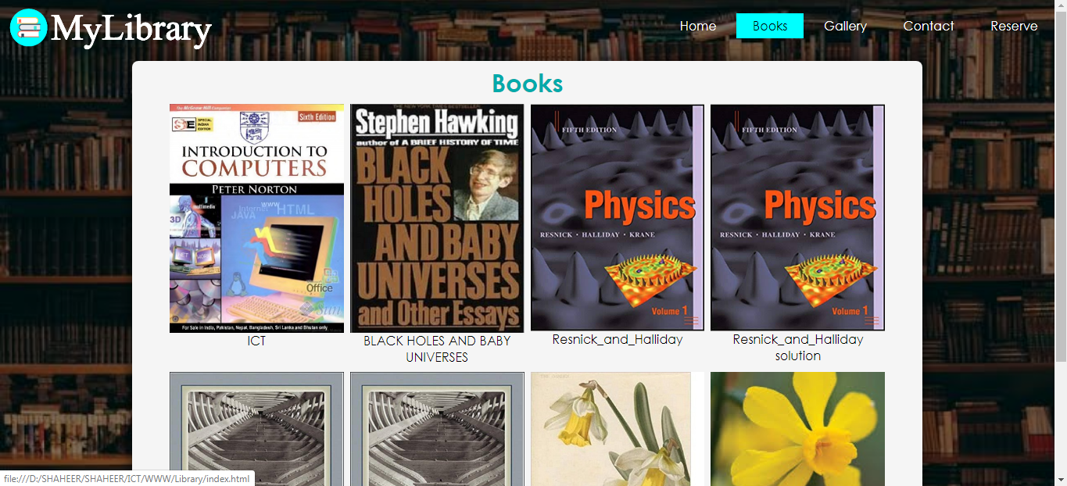

Figure BOOKS

### GALLERY PAGE:

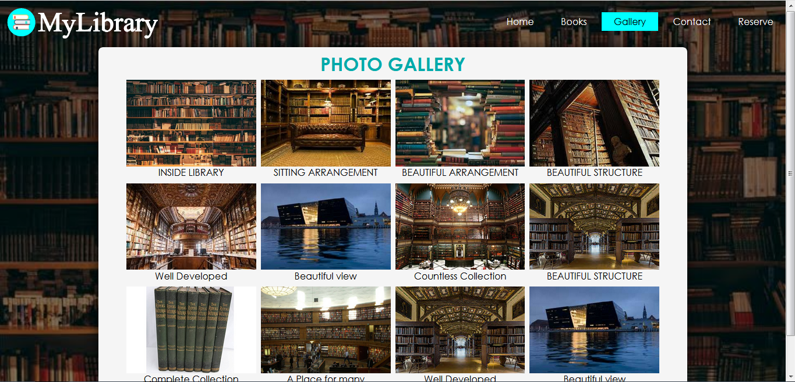

Figure GALLARY

### CONTACT PAGE:

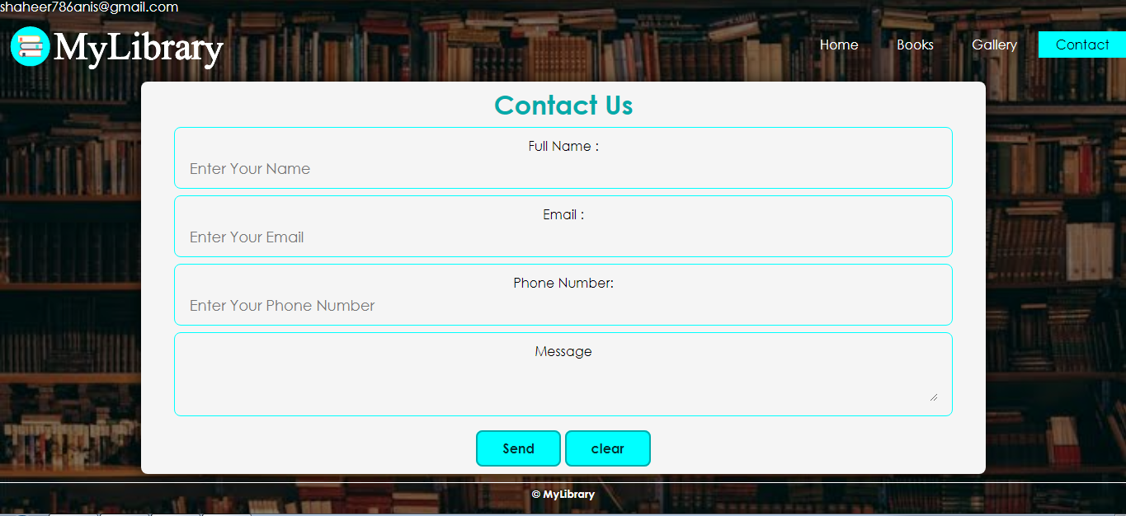

Figure CONTACT

### LIST OF BOOKS PAGE:

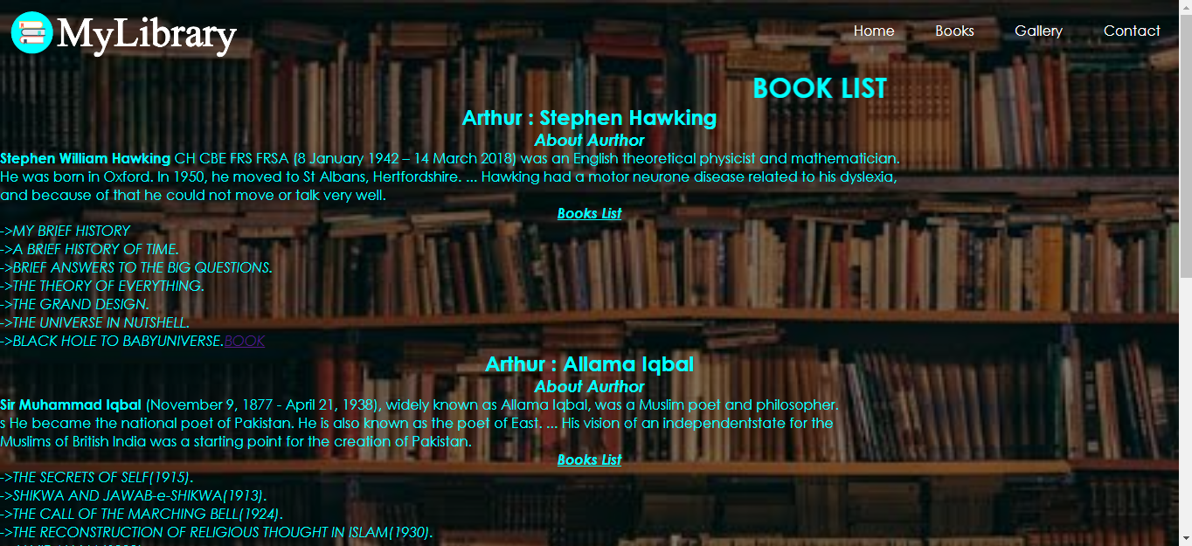

Figure BOOK LIST

### LEARN MORE:

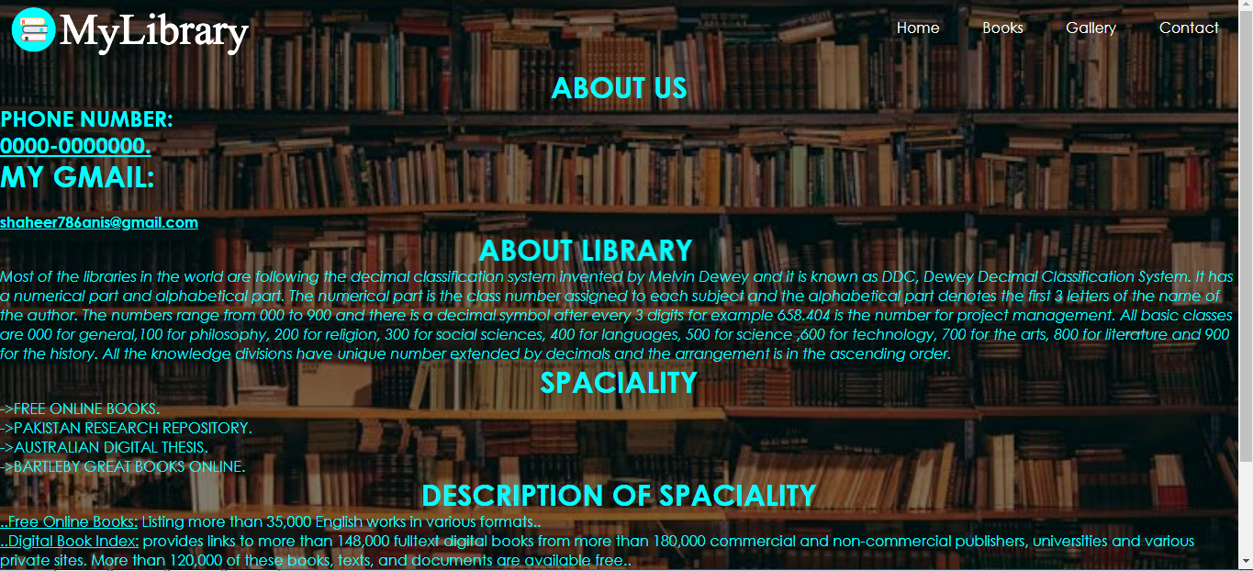

Figure LEARENMORE

Figure 1 HOME 7

Figure 2BOOKS 7

Figure 3 GALLARY 8

Figure 4 CONTACT 8

Figure 5 BOOK LIST 9

Figure 6 LEARENMORE 9